[**CREATE IBM WATSON IOT PLATFORM AND DEVICE**](https://github.com/IBM-EPBL/IBM-Project-46023-1660734780/blob/main/CREATE%20AND%20CONFIGURE%20IBM%20CLOUD%20SERVICES/CREATE%20IBM%20WATSON%20IOT%20PLATFORM%20AND%20DEVICE.pdf)

|  |  |
| --- | --- |
| **TEAM ID** | PNT2022TMID16047 |
| **PROJECT NAME** | Hazardous area monitoring for industrial plant powered by IOT |
| **MAXIMUM MARKS** | 4 |

**STEPS**:

1. Create an IBM Cloud account and login to the respective account

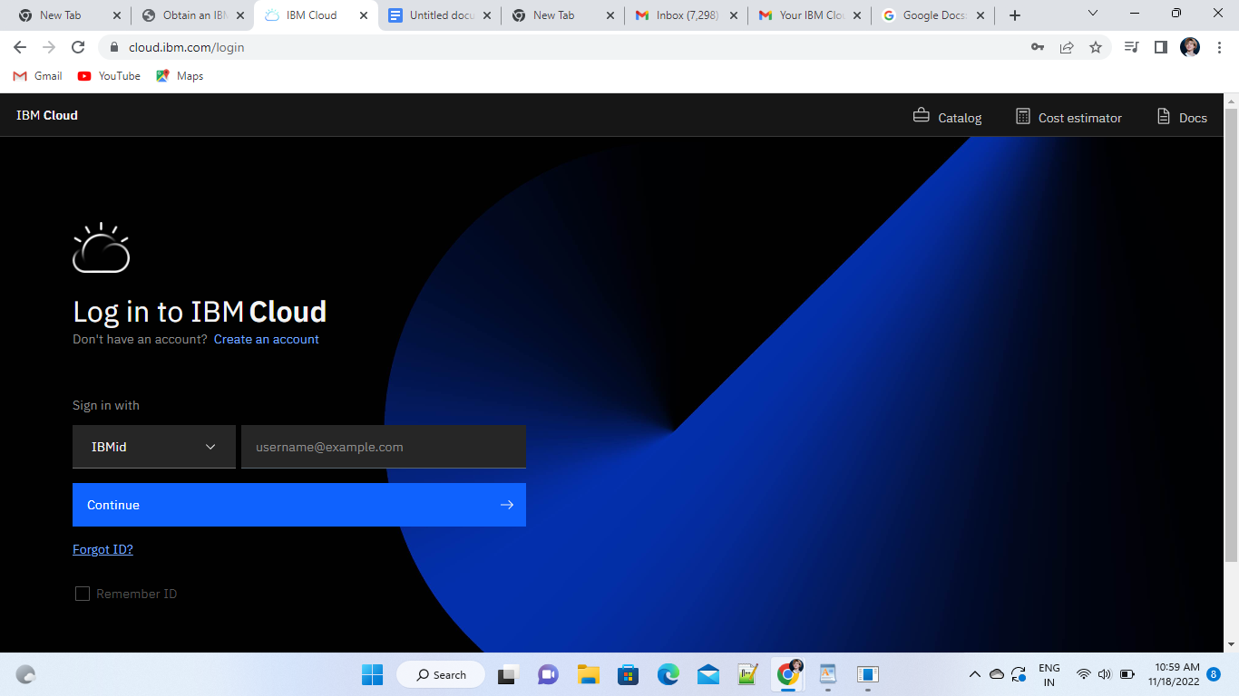

1. Dashboard of the IBM Cloud

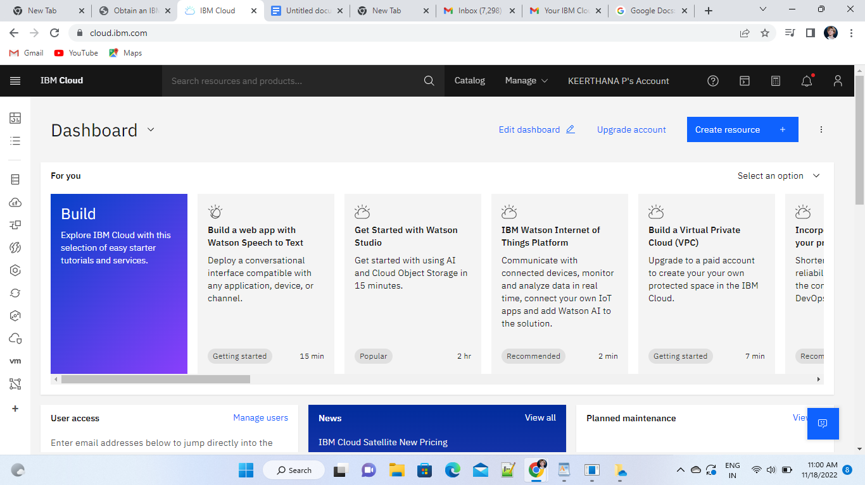

1. Click on the catalog on the top right. And click the Internet of Things present in the category list.

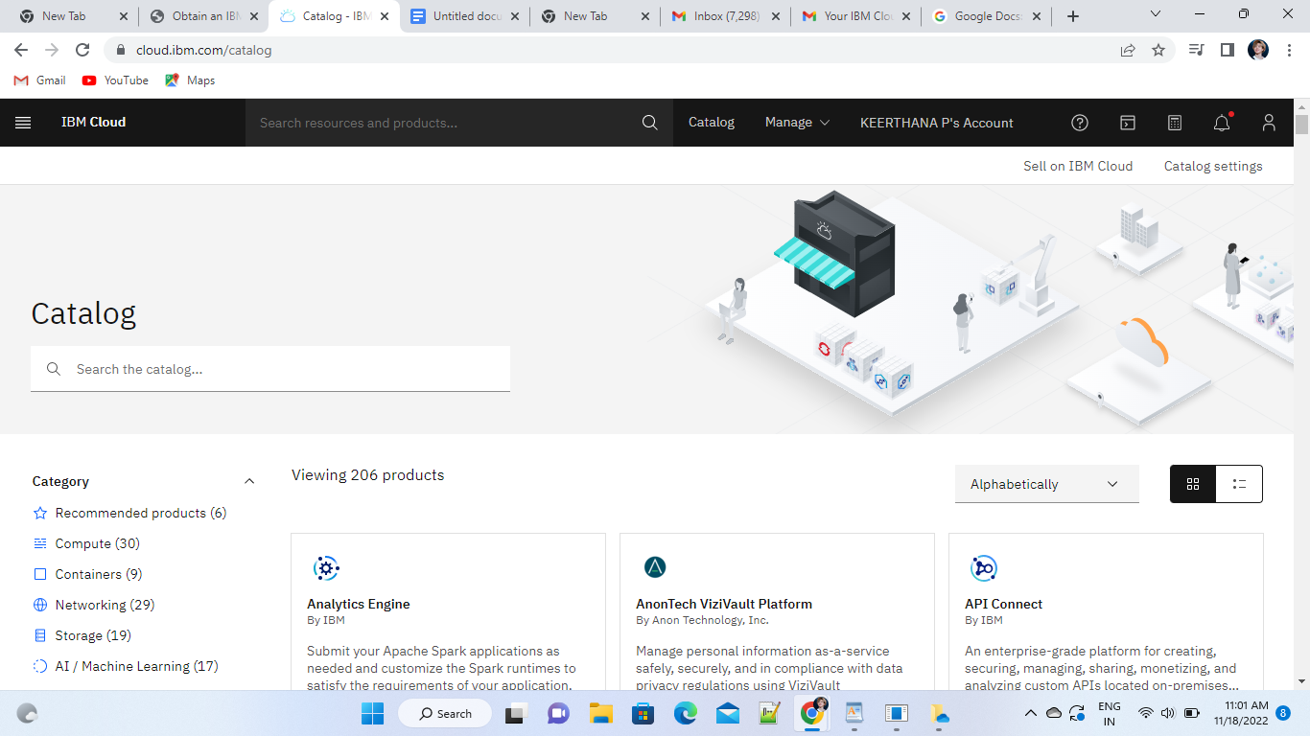

1. Click the license Agreement and select the create

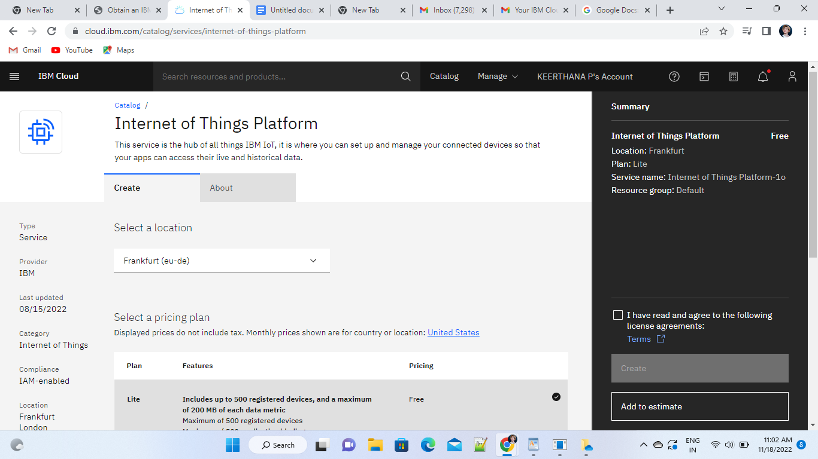

1. Click the launch button

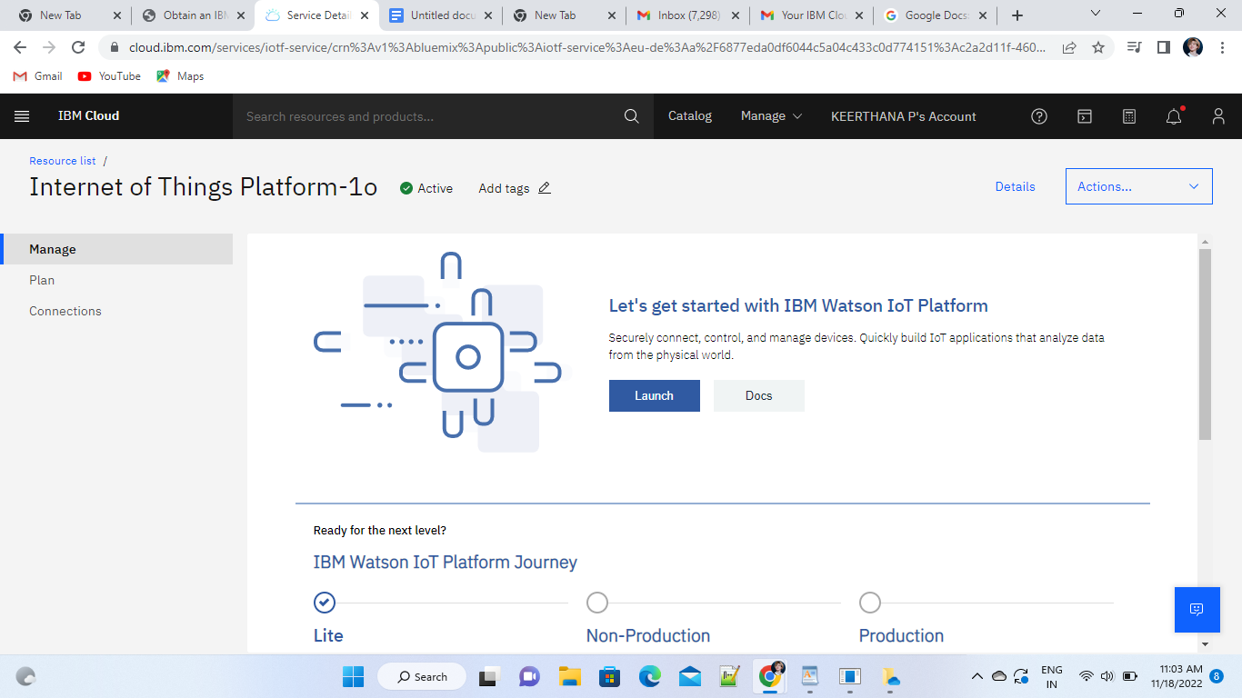

1. Sign in to the IBM account again

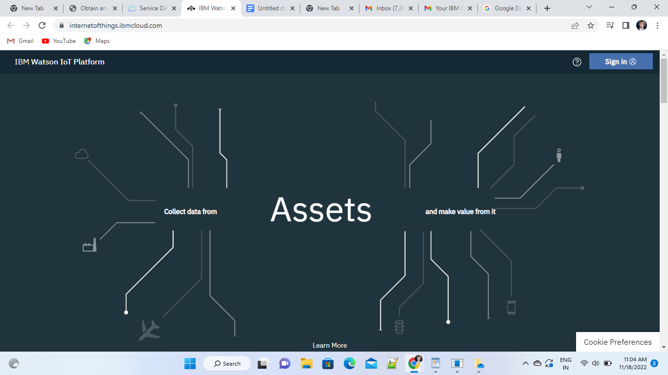

1. Click on the Add device on the right corner

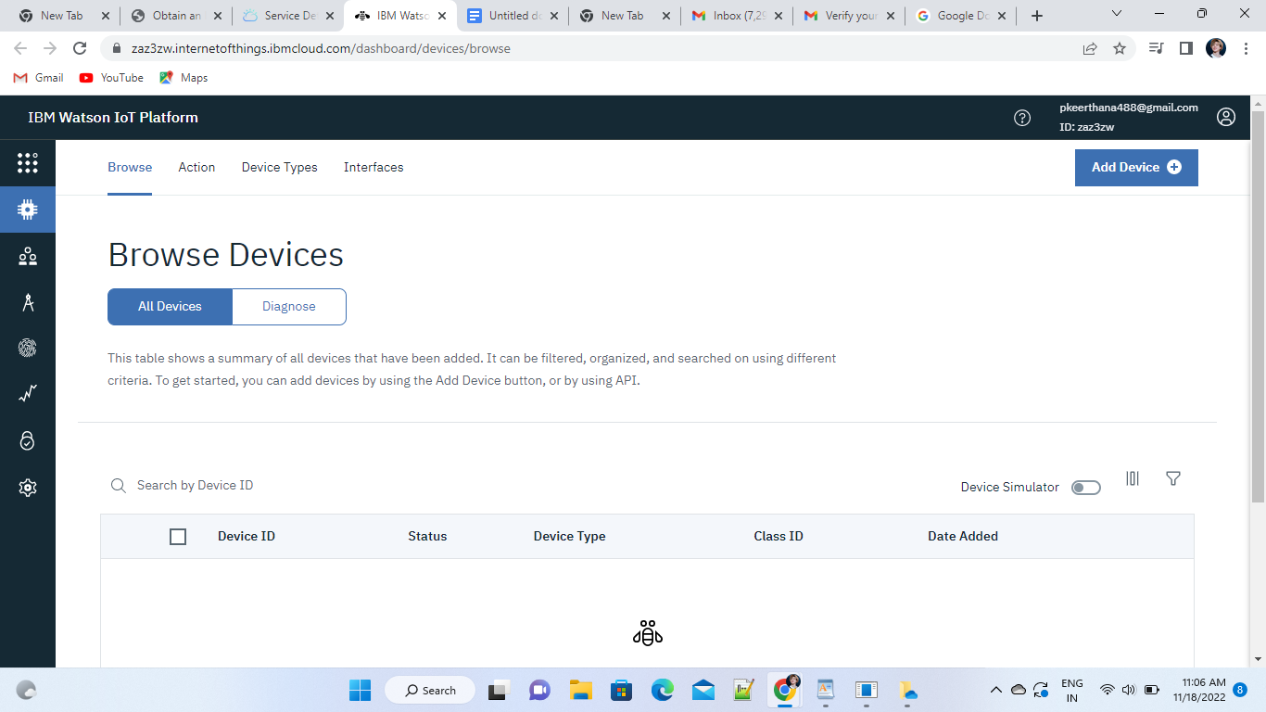

1. Type the device type and device id and click next

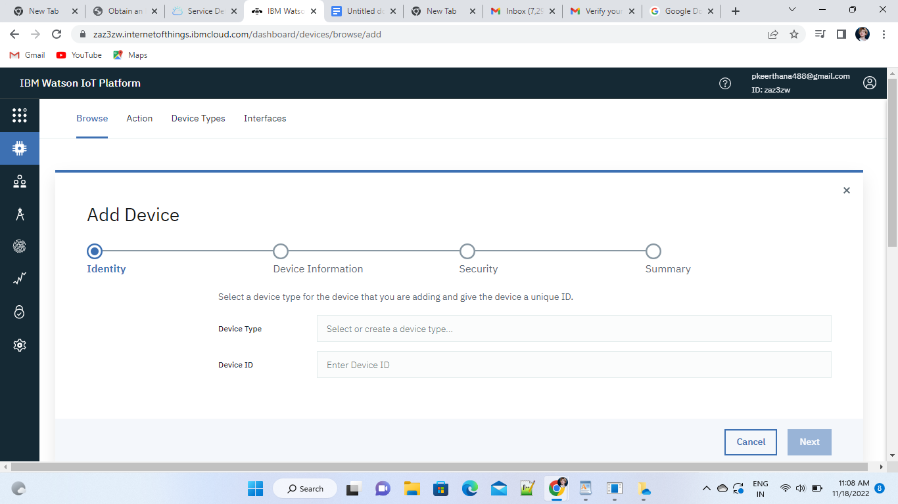

1. Click the next at the bottom

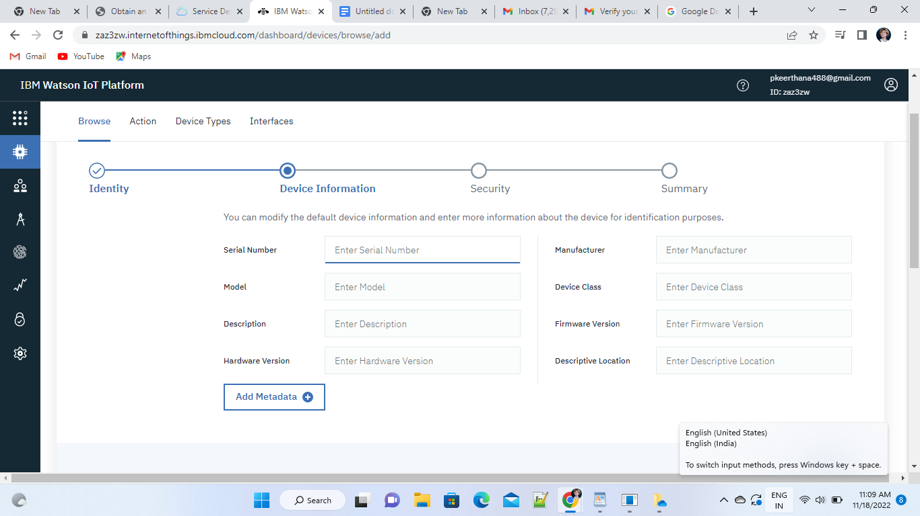

10.Enter the authentication token and then click next

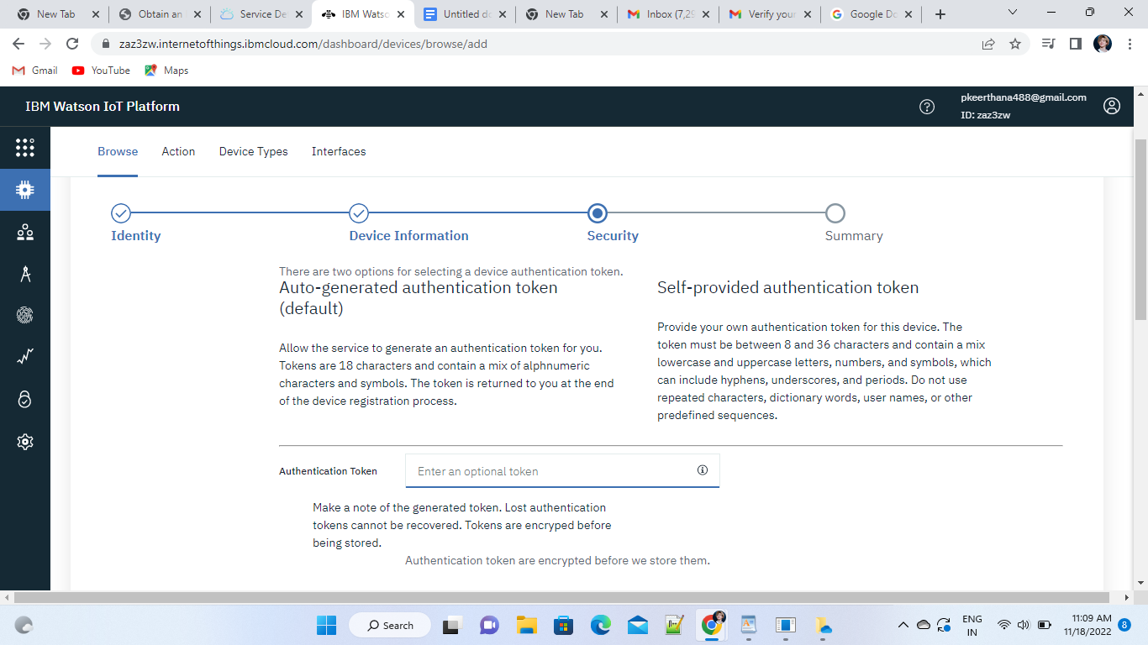

11.Click the next

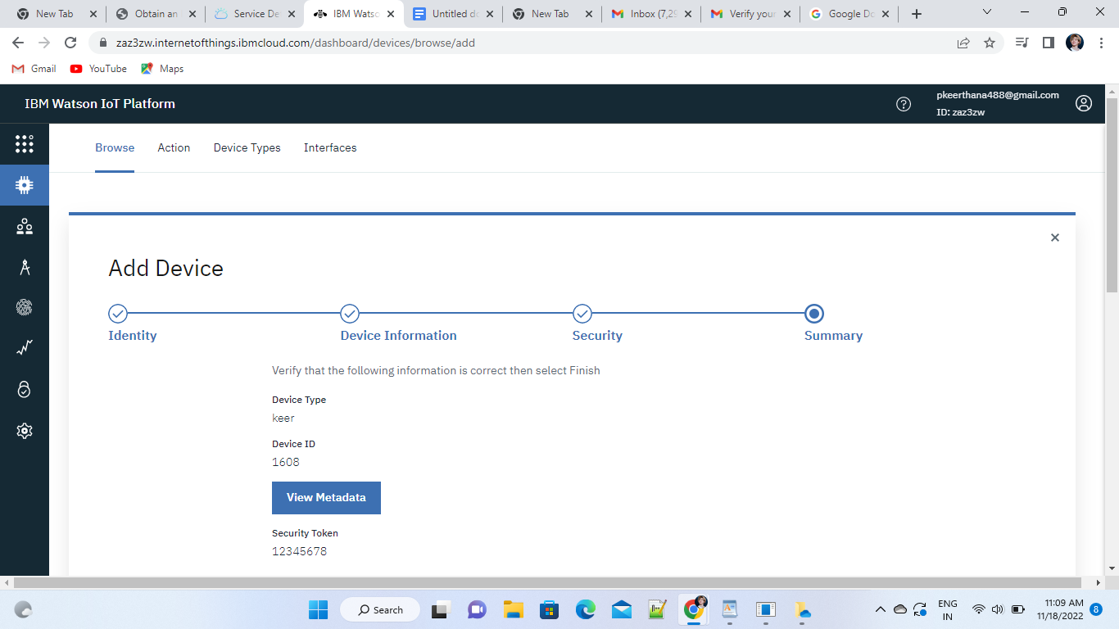

12. Device Drilldown page appear

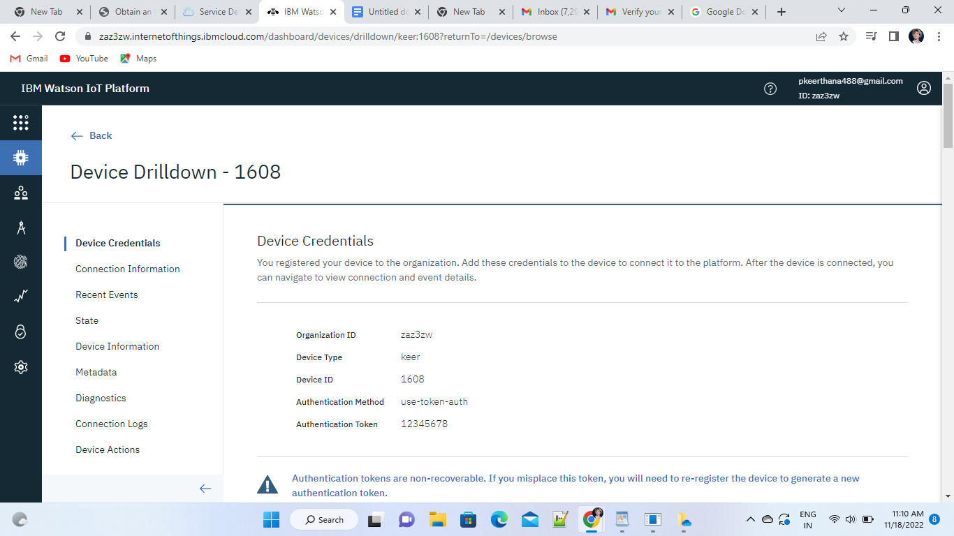

13. Click browse again to view the connectivity

